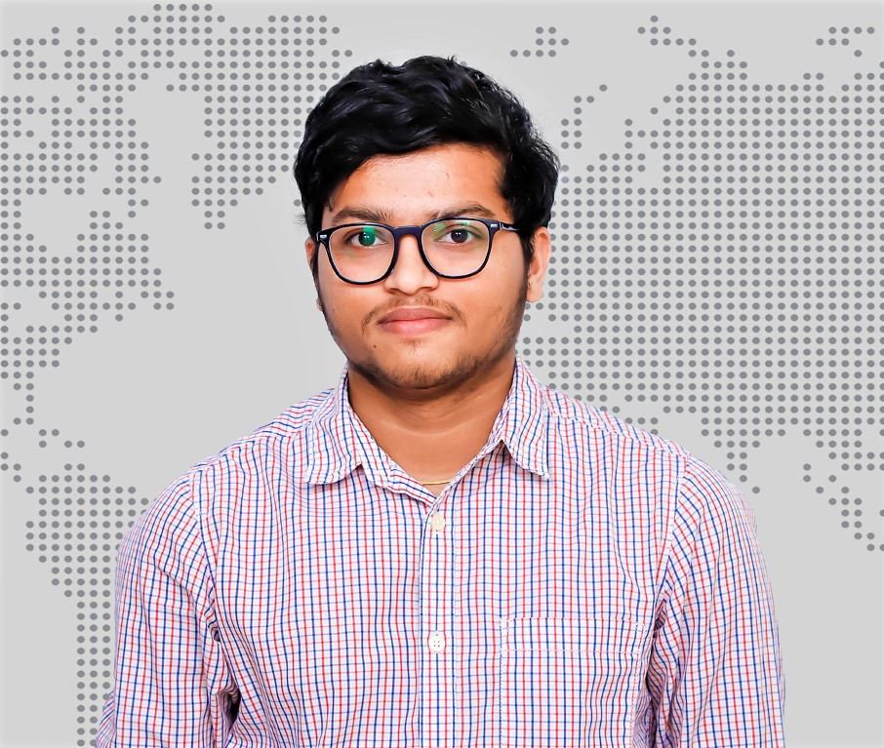

**AVINASH MADIWALAR**

**DEVOPS CONSULTANT**

**PROFESSIONAL SYNOPSIS**

Skilled ***DevOps Consultant*** with 3.6 years of Industrial Experience in architecting/automating & optimizing mission critical deployments over large infrastructure. Configuration Management, Continuous Integration, Continuous Deployment and Cloud Implementations.

**AREAS OF EXPERTISE**

Automation, CI/CD Pipeline automation with ***Jenkins***, Integration, ***Kubernetes***, ***Docker***, deployment, ***Git***, ***Nexus***, ***SonarQube,*** ***Azure Cloud Platform*** much more in DevOps eco system tools

**CERTIFICATIONS/TRAININGS**

* Certified as ***Oracle Certified Associate, Java SE 7 Programmer.***
* Trained in ***Kubernetes (CKAD).***
* Trained in ***Docker, Jenkins.***

**WORK EXPERIENCE 03/2018 – present**

* Working as an ***Azure/DevOps Consultant*** for ***msg Global Solutions India Pvt Ltd***

**PROJECTS**

**Project:** Mercedes Digital Key (MIC)

**Client:** Daimler, Germany

**Role:** Azure DevOps Consultant

**Responsibilities:**

* Deploy and manage highly available ***Kubernetes cluster*** on Mercedes Intelligent Cloud.
* Integrated Microsoft Azure with ***Private cloud*** (MIC) for deployment of ***microservice based*** project.
* Developed and Designed ***Azure DevOps*** pipelines to manage the resource across multiple subscription in Azure.
* Individual contributor in an ***agile*** framework which has Responsibilities like - Interaction with Business team in story grooming, reviewing story/acceptance criteria.
* Hands on experience in ***Azure Devops***, worked on Azure web application, App services, Azure storage, Azure SQL Database, Virtual machines, Azure AD.
* Experience with container-based deployments using Docker, working with Docker images, ***Docker Hub*** and ***Docker-registries***.
* Worked in ***Agile methodology*** and following scrum sessions.

CONTACT DETAILS

**** avinashmadiwalar@gmail.com

t.ly/8LqB

+91 9060436834

Bangalore-560087

SKILLS SUMMARY

* AWS Cloud Services
* DevOps Tools

TOOLS USED

* Azure DevOps
* Kubernetes
* Docker
* Jenkins
* GitHub/GitLab
* Helm
* Jira
* Shell Scripting
* Prometheus (L)
* Grafana (L)
* IBM WebSphere

EDUCATION DETAILS

* B.E in computer science

2017 batch

LANGUAGES

* English
* Kannada
* Hindi
* Learning Deutsche













**Project:** Agile Change Management (ACM)

**Client:** Daimler, Germany

**Role:** DevOps Consultant

**Responsibilities:**

* Worked in all areas of ***Jenkins*** setting up CI for new branches, build automation, plugin management and securing Jenkins and setting up master/slave configurations**.**
* Analyse and resolve conflicts related to merging of source code for ***GIT***.
* Implement, maintain and support reliable, timely and reproducible builds for project teams.
* Worked with development team to migrate Ant scripts to ***Maven***.
* Deployed the EAR and WAR archives into ***IBM WebServer***.
* Worked with development/testing, deployment, systems/infrastructure and project teams to ensure continuous operation of build and test systems.
* Experienced in branching, tagging and maintaining the version across the environments using ***GIT***.
* Worked in ***Agile methodology*** and following scrum sessions.
* Knowledge in ***Jira Dashboard*** for tracking the user stories
* Automated build and deployment using ***Shell Script*** to speed up the processes.